A semiotic analysis of the blog: Humans of New York

Medha Jha, 140701144, BAJC, Batch A

School of Communication, Manipal University

October 12, 2016

Table of Contents

Abstract 3

A semiotic analysis on the blog: Humans of New York 4

Review of Literature 6

Methodology 10

Semiotic Analysis 10

Conclusion and Future Study 18

References 20

Appendix 22

Abstract

The research aims at analyzing the photo blog – Humans of New York, started by Brandon Stanton. It includes semiotic analysis of the work presented by the blog to its audience. It also explores the various outcomes and the outreach that the blog has received, in terms of – humanitarian aid, crowd funding and citizen journalism. We will be seeing how every photograph clicked by HONY (Humans of New York) has a complete connotative meaning of its own, hidden behind the denotative meaning that can be simply seen by our eyes. It puts together every aspect of our society and humans – psychology, psychoanalytic, social, cultural, emotional, etc. – to give out the message through a simple photograph and caption. The photography blog, hence can be considered to have grown from a photo bog to a storytelling blog, as the length and impact of every passing post has kept increasing. Brandon has started focusing more on the in-depth storytelling to bring out the most impactful events and learnings from people’s lives.

Keywords: Humans of New York, HONY, semiotic analysis, humanitarian aid, social media, photography, crowd funding, blogging, citizen journalism, human interest stories

A semiotic analysis of the blog: Humans of New York

This research studies Humans of New York (HONY), a photography blog through a semiotic analysis. Humans of New York, a photography blog started by Brandon Stanton has become a worldwide phenomenon as it successfully fuses in photography, short-form narrative, and the interpersonal dynamics of the social media. (Girard, 2014) HONY was started as a photography project by Brandon Stanton in 2010 with the goal of photographing 10,000 inhabitants of New York City and forming an exhaustive catalogue of the same. ‘Somewhere along the way, I began to interview my subjects in addition to photographing them. And alongside their portraits, I'd include quotes and short stories from their lives.’ – Brandon Stanton.[1] (Stanton B., n.d.) HONY has over twenty million followers on social media with 17,891,801 likes on its Facebook page itself (as on August 31, 2016). With its worldwide outreach it provides the viewers with daily glimpses of the lives of strangers on the streets of New York City.

While, the mainstream media is amplifying the coverage of the tragedy and its suffrage among the people, Humans of New York brings out the stories of the victims. Amongst all the death tallies, human interest stories are getting lost. As most of the reports are presented in the general, monotonous ways to the people, they are getting detached from it. (Ghannam, 2016) There is no feeling of empathy or sympathy towards the news they read, watch or hear because of the same. ‘Individual stories are always unique and people would like to hear them.’ – Nabil Al Khatib, executive editor of Saudi owned Al Arabiya based in Dubai, UAE.[2] (Ghannam, J., 2016). Hence, HONY stands out amongst all these mainstream sources of information. HONY has also expanded to over twenty countries over the past five years to narrate feature stories from across the world. His work has also been released in two of the bestselling books - Humans of New York and Humans of New York: Stories.[3] (Stanton B., n.d.) While, blogging has become more important that ever before in today’s world, we can see how HONY’s outreach keeps increases manifold – simply because of its existence as a photo blog. It appeals to the audience as easily as it is shared by them. It has been talked about, taken inspiration from, and helped quite a few lives by influencing and bringing attention to people genuinely in need. It can be taken as a good example for a successful blog-cum-crowdfunding-and-citizen journalism website, which has pretty decently been helping people across the world. HONY puts forth the true, personal and individual stories of the people of New York, and across the world, which generates the sensitivity and empathetic nature among its audience.

HONY has also been actively touring the world in collaboration with the UN. From its trips to over twenty countries, which includes India, Pakistan, Uganda, Jordan, Iraq, Kenya, Mexico, etc., it has featured many stories of the people from these countries. It has also successfully associated itself with various causes and come up with various photo series exclusively featuring the people involved in the same, like – Pediatric Cancer, Inmate Stories, Syrian Americans and Refugee Stories. These stories focus on specific populations, examining their experiences and the challenges that they face. [4] (“Series,” n.d.)

# Review of Literature

Humans of New York has been growing rapidly since its inception, and is continuing to do so. Hence, its presence is quote majorly seen and felt across all new media channels. There have been many writing about the same and critically analyzing its growth, existence and impact. Mirchandani, T. (2015, April 23) presents HONY as a stunning example of community engagement through social media and how powerful it is as a medium of storytelling. He also emphasizes on the fact about how it has also become a model for crowdfunding, and how it has been successful in changing a lot of lives because of the same. According to Mirchandani, T. (2015, April 23), HONY enjoys a numbers of factors that not all NGOs or fundraisers enjoy – like, a thriving social media presence, regular coverage by the media, and a variety of speaking engagements. But, in spite of that, Stanton has his own magical way of persuasion and an ability to move his audience by posting just a photograph and short interview or quote by the subject. He stays plugged into his community and he focuses on what engages them. And when he finds the thing that hits, he pushes it forward. (Mirchandani, T., 2015) He never sets out with his camera with a pre-decided objective of raising funds or supporting a cause which enables him to easily achieve a balance in the way his posts are put through to the public, and it does not seem excessive.

Balabanovic, Chu, Wolff (2000) put forth the idea that people usually alternate between photo-driven and story-driven methods while telling their stories about their photographs, as validated and revealed by a user test. They also put out the fact about photographs and its most common and enjoyable use, i.e., to share stories of one’s experiences, travels, family and friends. Everybody has had an experience with this particular form of storytelling as it ranges all the way from reminiscing memories to cultural history. With the advent of the World Wide Web, the sharing of photographs has furthermore been facilitated by sharing stories in digital form and inspiring the movement towards digital storytelling. HONY is one of the most successful examples of this movement.

As mentioned by Girard, R. (2014), HONY cannot be simply classified as a photojournalism project, nor can it be viewed as strategic advocacy campaign on social media, since no clear points of view or action-based goals are mentioned. Yet, with his multifaceted approach of fusing together photography, short-form narrative, and the interpersonal dynamics of social media—HONY has developed its own communicative formula which interests and is appreciated by millions across the globe. It has brought people together online, standing up for a cause as the awareness and empathy towards topics like homelessness, mental health, immigration, homosexuality, race, and religion – were brought forth; while, a lot of followers have considered it a more authentic source of information than news reports. Lucaites and Hariman (2001) as cited by Rosemary G. (2014) assume that photographs often “reflect social knowledge and dominant ideologies, shape and mediate understanding of specific events and periods…influence political behavior and identity, and provide inventional (figurative) resources for subsequent communicative action” (p. 37-38). Images, in contrary to text, can often be more salient in viewers’ memories as they are “less intrusive than words and…require less cognitive load” (Rodriguez & Dimitrova, 2011, p. 50), and may activate peripheral rather than central processing. The persuasive power of images might be subtler, but just as moving as any written language.

The research by BBC Media Action (2016, July) shows that though there are several challenges that have to be faced for an effective communication with the people affected by refugee crises, there are several opportunities of doing so as well. The needs highlighted by the refugees include the need for more translators, face to face communication and support in communication around the legal issues. The research also highlights that many refugees feel that their voices are not being heard, neither are their questions being answered by anybody. Which is leading to them being frustrated and losing trust. Hence, it can be concluded that there are a number of ways in which communication will play an important role in supporting people stranded during refugee crises. HONY has successfully worked on a series based on the same, by communicating the real, raw stories by the refugees themselves. This series of HONY touched millions of heart, and brought together the public towards a better cause.

Furthermore, photography has for long been used instrumentally, by not just telling contemporary stories, but also to bring light to many social realities. Jacob Riis, a reformist journalist used his photographs in his book – “How the Other Half Lives” – to uniquely showcase, both artistic and documentary ends at once. His photographs had deep writing and skillful reportage connecting deeply to the photographs taken by him. (Cunningham et al., 2015) It has also been successfully used as a wartime tool for the army’s public relations during the Iraq war, when the US soldiers serving in Iraq documented their experiences and posted it on the internet. (KENNEDY, 2009) During the Great Depression times, the novelist Erskine Caldwell and the photographer Margaret Bourke-White travelled together through the rural South, with a hope to gather impressions from the lives of black and white tenant farmers. The resulting book, “You Have Seen Their Faces,” can be considered to be the direct ancestor of HONY, as each of the photographs taken by Bourke-White’s in the book, is a melodrama in black and white, adorned with an illustrative caption. “A barefoot black boy in East Feliciana Parish, Louisiana, stands surrounded by newsprint-papered walls, a dog at his feet. ‘Blackie ain’t good for nothing,’ the caption says. ‘He’s just an old hound dog.’ A white man, jowly, with round glasses, gazes skyward: ‘Beat a dog and he’ll obey you. They say it’s the same way with the blacks.’” [5] (Cunningham et al., 2015)

HONY, can hence be seen as a modern day photographic storytelling book, in form of a blog, which have surely come up recently to take over media on the internet. Majority of the users are aware of the positive changes, that includes learning experiences because of blogging in everyday life. The changes may not be physical, but they are intangible, such as ways to deal with information and knowledge, personal ways of thinking, self-development, and social relationships. In examining the usefulness of blogging in the learning process, the majority of participants believed that blogging is valuable in acquiring specific knowledge, expressing thoughts and opinions, and expanding one’s interests. [6] (Park, Heo, & Lee, 2011)

Which brings us to the very fact that the mainstream media has been drastically affected by the new web-based media which is easily accessible, and at the same time influential to the audience. Mainstream media - television, radio and newspapers - were once considered the primary source of news. But this was long before the age of the Internet. News websites, some of which are hosted by media entities, have become sources of alternative news. Before the advent of the Internet, alternative sources of news were restricted to community or alternative newspapers and to some extent, community radio. Today, user-generated content as news is clearly a growing phenomenon as original reporting of local events contributed by ordinary citizens continues to increase. Eyewitness accounts are, at times, fuelling the reportage in mainstream media.[7] (BARNES, 2012)

# Methodology

The research paper is based on the qualitative method of research, particularly semiotic analysis. Qualitative research primarily being an exploratory research, it would aim at exploring the different angles and impact of photo-storytelling-blog HONY.

The research has been backed up by the priming and framing theory, which states that “Media provides a context for public discussion of an issue, setting the stage for audience understanding. Media provide a focus and environment for reporting a story, influencing how audiences will understand or evaluate it.” [8] (Smith, n.d.)

Linking the theory to the research paper looks at how the the digital storytelling form of media has been influencing the audience. It also is a type of reporting, i.e. citizen journalism – as it includes human interest stories, hence it initiates the feeling of closeness by impacting the audience personally.

# Semiotic Analysis

The researcher has picked few of HONY’s most talked about posts and analyzed them through denotation and connotation. HONY always recognizes and uses recognize the themes of human condition, including love, loss, failure, success, and more in a productive way to resonate to its audience successfully.

Denotation: Figure 1 shows a man, probably in his late 40s lying down on park bench with his travelling backpack under his head, and a book in his hand. His legs and crossed and he is decently dressed in a grey t shirt with black pants with black shoes and white socks. He has a watch on his left hand and back rectangular-framed-black glasses. He is looking sideways into the camera with not-so-interested a look. And, when the photographer asks him about his largest remaining goal in life, he answers by saying, "I'm just a tourist in this world. I'm not trying to affect anything." Connotation: It can be seen by the man’s attitude and behavior, that he is a carefree soul, who minds his own business and does not bother to be involved in anybody’s business. He refers to himself as a tourist which clearly talks about how his mindset is bent towards being by himself and not letting himself affect others life. He is satisfied being on his own, and doing things on his own, like in the picture – how he is reading his book by his own on the side bench. This also connotes that he a person who would not be involved in petty things such as gossiping about others, hating people or things they do, being affected by others behavior or reacting to negative people, or people in general. He is just bothered about himself and how he carries himself off, and does not like interfering in somebody else’s world.

Denotation: Figure 2 captures a nuclear Indian-Punjabi family – the mother, the father and their son. The father and mother must be in their mid 30s and son must be 6-7 years old. The mother and son are dressed up in a typical regular-punjabi attire, while the father is in semi-formals with a bag on his shoulder and a turban on. The mother is in a salwar kameez with a white base and red flowers (probably hibiscus) and leaves printed all over it. She has braided her hair which would be quite long, and she is wearing a bindi. She also has a necklace on with bangles on her wrists, earrings on her ears and nose ring as well. She has a red colored lipstick on, with red chappals and a brown bag. She his holding her son with both her hands while posing for the photograph. The father is formally dressed in a pink checked shirt and beige striped pants, with black formals shoes on. He has a black back on one of his shoulder, a maroon colored turba, kada on his right wrist, long beard, and a brown belt. He is lightly holding his son’s wrist while posing for the photograph. The little boy is in a white kurta and black Patiala, with sandals on. He has a black neckpiece tied around his neck and is giving a straight-face look to the camera. Connotation: The family oozes out the feeling of calmness and honesty from them, as they innocently pose for the photograph. By the answer that they gave to the photographer’s question it is clear that they do not fall under the category of a typical Indian parent who wants their child to become a doctor, a lawyer or an engineer – by not giving them a chance to think at all. They believe in letting their child dream by himself and make his way through this world. This shows the courage and confidence that’s truly incorporated in them, despite being such simple souls from the outside. We can also figure that the family is not so financially well-off, and the father is doing a regular 9 to 5 job, to earn his living, but in spite of that, them being able to believe in their son to do what he dreams of truly defines their personality and honesty.

Denotation: Figure 3 has a little girls dressed in white sitting on the floor, barefoot. She has blonde hair tied into two ponytails with white clips on her head. The location is of an interior in a building, with two people been blurred out in the background. There clearly is an adult, mostly one of her parents, present there who is answering the photographer’s question. Connotation: The little girl is being allowed to be exposed to different cultures, as her parents let her play with all the children on the street. Children pick up languages and habits very easily from others and so has she while playing with the kids on the streets. She is able to speak more languages that anybody else in the family at such a young age with is a big deal as not everybody is able to do so. Her innocence and sincerity can be clearly seen on her face and she gladly poses by looking at the camera confidently.

Denotation: Figure 4 shows a middle-aged woman with a broad smile and a headband made of roses. The caption has his asking her what inspires her, to which she replies saying, “Colors, flowers and picnics”. Connotation: Here, we can see how intricately it has been related to the photograph taken by him which clearly emphasizes on the colors she’s wearing – the pink lipstick, with the similar colored highlights on her hair. While the flowers on her head clearly portray her love for them. While we can associate her inspiration from picnics, to be having a child-like personality, and to take things as they come by. That also can be seen on her face, in her smile and lighted up eyes, and also through her simple dress sense.

Denotation: Figure 5 has a woman facing her back towards the camera with a long tattoo on her back. According to the caption provided, the tattoo read: ‘When birds look into houses, what impossible worlds they see.’ Connotation: This quote is able to relate to her personality as well. Her outfit portrays how carefree her nature is, and that she is like a free bird. She is a person who cannot be controlled or caged – similar to the entire ideas in the photograph where she is not even looking at the camera. The photograph has been successful in capturing her entire personality reflected upon by her dress sense and body language.

Denotation: Figure 6 captures the image of a young, pretty lady dressed in a kimono with a red umbrella and a red shopping bag which she proudly displays while posing for the photo. The lady is very well dressed, with proper make up and hairstyle, and even matching footwear. The caption has her telling the photographer to make sure he can see the bag. To which, he asks if she is advertising something, and she gives a smart reply by saying, “Isn’t everything beautiful advertising something?” The bag is from a Japanese multinational personal care company, that is a skin care, hair care, cosmetics and fragrance producer. It is one of the oldest cosmetics companies in the world. Connotation: Her being dressed in the typical Japanese attire with the umbrella, and shopping for authentic Japanese product shows how much she is rooted to her origins. She carries herself off beautifully and is confident about her looks, attire and personality. She also brings in the angle of advertisement being always related to beauty, which in fact is true for most of the MNCs across the world. Her elegance is seen through her eyes as she looks right at the camera lens and gives that slight smile.

Denotation: Figure 7 captures a man with long hair, a nose piercing, a cap, spiked jacket, and blue shades with a black cat on his shoulder. He tells the photographer that he found the cat in the trash and named him Shadow as he followed him everywhere. Connotation: The man’s look clearly tells that he lives on the street, and petty chores to earn his living. In spite of not being financially stable, he seems to be a caring man, as he took up the responsibility of taking care of the cat. He is also a smart man, which can be noted by his reply in which he says he named the cat Shadow as he followed him everywhere. That is commendable, as not everybody can come up with something so easily. He also clearly loves the cat as he has kept him close to himself and tied a belt around its neck as well to make sure people don’t think its stray as it belongs to him. Even though he found the cat in the trash, he loves and respects him immensely. This shows his kind nature and expectations from the society, where people usually look down upon people who are from the streets and look dirty. Probably, there has occurred a situation were he has been treated badly due to the same, hence he understands the importance of respecting and loving all equally.

Denotation: Figure 8 captures a young man, probably in his early 30s, with a Mohawk, dressed in all black – black vest, black capris, black boots, black wristband and black shades hanging from his vest. He also has tattoos on his body and is pretty well built. He says that he was in jail for 8.5 years as he was charged with an attempt to murder case, while trying to protect his sister from a thirty-year-old man who kept harassing her. Connotation: His look and reply to the question clearly shows that he has major anger issues, along with with being very possessive about his close ones. He loves his sister and that is why couldn’t take anybody harming her in anyway, even though that took 8.5 years of his life away. He has a soft heart inside that tough body and is a person who seems serious, weird and scary to most people, but only until they get to know him. After that, he might just be the most fun person they have ever met!

Denotation: Figure 9 captures an old man, probably in his 50s, with a cigarette held tightly by his lips, a cap ‘Vietnam Veteran’ probably (it is not clearly visible), torn clothes and unshaved facial hair – which clearly indicates that he is from the streets and does not have a secured job. When asked by the photographer, he reveals how he has suffered the loss of his parents and seen his closest friends die in Vietnam. Connotation: He refuses to categorize his sad moments as he has seen many while being through the Vietnamese war. He believes that life is full of bad and good experiences, but they’re all overlapping each other, and it’s that which keeps life going and provides each individual with their very own stories. This is probably what he is trying to propose through his rubber band ball theory.

Denotation: Figure 10 captures a dog which has two different eye colors. Connotation: Though the owner of the dog is not seen in the photograph, the man answering the photographer’s question seems to know him as he tells that the owner of this rare dog has told him that according to the native American myth, dogs who have different eye colors can see both earth and heaven through them. The dog being a very rare, yet unique sight must be capturing a lot of people’s attention around him. If look into the photograph in parts, i.e., one side at a time, we can clearly make a difference in the way the dog is looking at us through the camera. Hiding the left side of the photograph (dog’s right side), we see the dog looking at us as normally as any other dog would, with their sparkling innocent looking eyes. But, if we hide the other half of the photograph and look at the dog’s eyes then, it clearly seems unnatural, and quite contrasting to the way the other eye looks. Its scary as well as equally fascinating at the same time.

Denotation: Figure 11 captures an Indian girl, in a black furry jacket with an unconventional haircut, ear piercings and giving the ‘what the hell!’ look to the camera, which is clearly justified by the caption. Connotation: This photograph majorly emphasizes on the societal stereotypes that are generally let go off easily, which in this case, the girl did not. She answered back pretty coolly after being stereotypes as being an Indian and hence getting asked out for a date by someone who must be having a thing only for Indians. The courage, confidence and strength the girl possesses is clearly visible on her face and personality and with her look saying – ‘You better not mess with me!’ – nobody would really dare to do so.

Denotation: Figure 12 captures a cute little baby dressed in all pink laughing with all her might. Connotation: This photograph is something that is the most-basic way of capturing images and captioning them, by HONY. This is how he started and got his outreach which enabled him to grow further and further. It’s just a happy photograph which resonates happiness into everybody who looks at it, and brings a smile to their faces.

Denotation: Figure 13 captures an old lady, probably in her late 50s, sitting on a table with a book in front of her which she is holding with her left hand. She is wearing a jacket and sitting with her right hand on the back rest of her chair. The ambience looks like a royal antique one, which probably could be a library. Connotation: Her smile tells us about her fun personality and daring nature which is emphasized upon by the answer she gives. She believes in herself, and will never compromise for anybody. She can be truly called a self independent woman who does not care about what others think, unless she is on the right track, everything will eventually fall into place. She believes in growing as a person is important and nobody should give up on their dreams for others. This is a life lesson major chunk of teenagers require, as they are the ones who get influenced very easily.

Denotation: Figure 14 shows a middle aged man, with unshaved facial hair and long hair dressed in black with a black backpack. He is reading a book sitting on the side of the street which hints at him being homeless. He is holding a cigarette in between his lips as he poses for the photograph. We can see a busy city life in the background and a little mess created around him. Connotation: The man is least bothered by the hustling and bustling of the city life around him, as he is engrossed in his own world while reading his book. He has read over thousands of books but is still homeless, as he can not continue with any job for long as it makes him sad after a point, every time. This is ugly reality of our society, where people are unable to live their lived the way they want, by doing what they want, just because of the standards set by the society. It is difficult for a person to come up unconventionally, or by being different than the others.

Denotation: Figure 15 shows a happy middle aged woman who has recently been fired from her job as a school teacher as she wanted to have a socially conscious class who would know about the realities of the world and be empathetic towards it. This idea of hers did not really match with that of most around her, hence she was asked to leave. Connotation: Despite of being fired recently from her job, she has not lost hope, and still is a happy soul as she truly believes in herself and her idea which are not wrong at all. It is difficult to make others differentiate between the socially right and superficially right matters. But, her hope and positive-ness might someday make her successful in doing so. It is rare that somebody has such a happy-go-lucky personality, and knows how to deal with every atrocity with a smile on their face.

Denotation: Figure 16 shows a man sitting on the roadside in all black, he is homeless and has a diary with him where he was writing something before being photographed. He tells the photographer how her daughter is unaware about him being homeless, as he doesn’t want to add to her troubles. Connotation: He is an ideal example of any loving father who would never want to be a burden on their kids, as they love them so much. He wants her to succeed in life and achieve her goals, even though he might have to suffer for it. As he believes in her and is courageous enough to do so. He is immensely proud of her and she is her happiness, and he would not in the world want her to be hurt at any cost, hence he is hiding the fact of him being homeless from her. We can figure that he is a calm, and kind man who believes in the good in this world.

# Conclusion and Future Study

In the paper by Rosemary G. (2014), a Neo-Aristotelianism (rhetorical criticism) has been carried out, and the research focuses on how HONY has evolved from its inception and how people have perceived it, for it to gradually grow. This research paper includes a semiotic analysis of the blog and focuses on its evolution from a photo blog to storytelling blog. It has covered the different aspects of HONY – from it’s importance as a platform to convey human interest stories to the world, creating crowdfunding and awareness campaigns about issues unknown to us, looking back at history to draw relations with similar attempts of photography-storytelling/reporting, to the present day scenario of citizen journalism and HONY’s major impact on the same.

Today’s world, especially the media is filled with images and multimedia content. It is necessary for any media user to be well equipped with the usage of the same. Photographs, in today’s era, truly speak a thousand word and impact human psychology in a completely different way than words. Hence, it is quintessential to study it thoroughly.

The researcher feels that there is a lot of scope for further research on the blog, in terms of measuring its actual impact and subsequent impressions thereafter. This would require an extensive quantitative and as well as qualitative research with a large base of target audience, who will be the prospective respondents. This can successfully be carried out in an area, preferable New York itself, where majority of the population are aware and impacted by its existence.

References

Balabanovic, Chu, Wolff, M., Lonny L., Gregory J. (2000, April). Storytelling with Digital Photographs. (Accessed: 11 October 2016).

BARNES, C. (2012). Citizen journalism vs. Traditional journalism: A case for collaboration. *Caribbean Quarterly*, *58*, 16–27. Doi:10.2307/41708775 (Accessed: 11 October 2016).

BBC Media Action. (2016, July ). (Accessed: 11 October 2016).

Cunningham, V., Wiener, A., Borowitz, A., Tolentino, J., Yorker, T. N., Wallace-Wells, B., … Gopnik, A. (2015, November 4). Vinson Cunningham. *Page-Turner*. (Accessed: 11 October 2016).

Denveater (2009). The virtual roundtable: Food Blogging as citizen journalism. *World Literature Today*, *83*(1), 42–46. Doi:10.2307/20621475 (Accessed: 11 October 2016).

Ghannam, J. (2016, April ). Media as a form of aid in humanitarian crises – center for international media assistance (Accessed: 11 October 2016).

Girard, R. (2014). Rosemary Girard communication criticism (SCOM 381) Neo-Aristotelian criticism of “ humans of New York ” on Facebook: Part 1. (Accessed: 11 October 2016).

KENNEDY, L. (2009). Soldier photography: Visualising the war in Iraq. *Review of International Studies*, *35*(4), 817–833. Doi:10.2307/40588076 (Accessed: 11 October 2016).

LAPP, D., SHEA, A., & WOLSEY, T. D. (2010). Blogging and audience awareness. *The Journal of Education*, *191*, 33–44. Doi:10.2307/42744142 (Accessed: 11 October 2016).

Mirchandani, T. (2015, April 23). Webinars. (Accessed: 11 October 2016).

NicoleBeachum. (2015, February 7). Blogging is more important today than ever before. (Accessed: 11 October 2016).

Ownby, T. (2013). *Online journal of communication and media technologies special issue – critical visual methodology: Photographs and narrative text as a visual Autoethnography*. (Accessed: 11 October 2016).

Park, Y., Heo, G. M., & Lee, R. (2011). Blogging for informal learning: Analyzing Bloggers’ perceptions using learning perspective. *Journal of Educational Technology & Society*, *14*(2), 149–160. (Accessed: 11 October 2016).

Parsa, A. F. *VISUAL SEMIOTICS: HOW STILL IMAGES MEAN? INTERPRETING STILL IMAGES BY USING SEMIOTIC APPROACHES*. (Accessed: 11 October 2016).

Smith, R. Agenda-setting, priming & framing. (Accessed: 11 October 2016).

Sonesson, G. *Semiotics of photography — on tracing the index*. (Accessed: 11 October 2016).

Stanton, B. About Retrieved from <http://www.humansofnewyork.com/about> (Accessed: 11 October 2016).

Storm, C. Meet 12 unforgettable “humans of New York.” Retrieved October 11, 2016, from Business Insider, <http://www.businessinsider.in/Meet-12-Unforgettable-Humans-Of-New-York/articleshow/43363754.cms?format=slideshow> (Accessed: 11 October 2016).

Wahl-Jorgensen, K. (2015, October 9). Humans of New York isn’t journalism, but it helps us get beyond the headlines. (Accessed: 11 October 2016).  
  
Additional Bibliography:

Stanton, B. (2014). Humans of New York. New York: St. Martin’s Press. United States of America.

Notes provided by the professor, Mr. Padma Kumar on Semiotic Analysis.

Appendix



Figure 1: "What's your largest remaining goal in life?" "I'm just a tourist in this world. I'm not trying to affect anything."

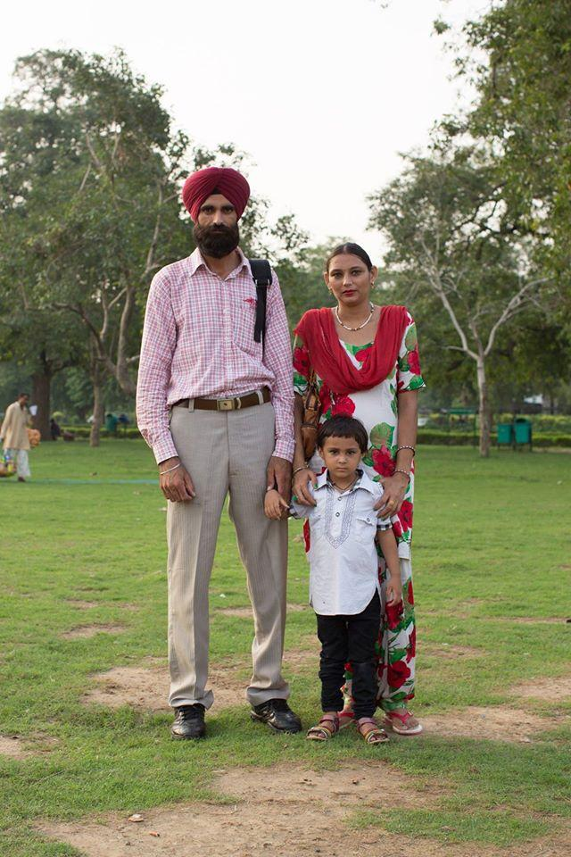

Figure 2: "What’s your biggest dream for your child?" "We’ll let him dream for himself." (New Delhi, India, September 2014)

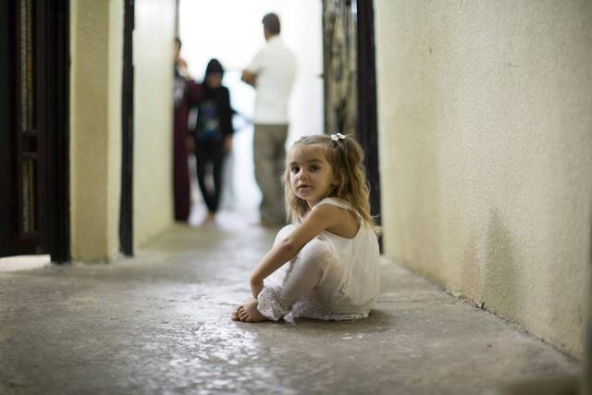

Figure 3: “She speaks more languages than anyone in the family. Because she plays with all the children in the street.” (Erbil, Iraq, August 2014)



Figure 4: ‘What inspires you?’ ‘Colors, flowers, and picnics’

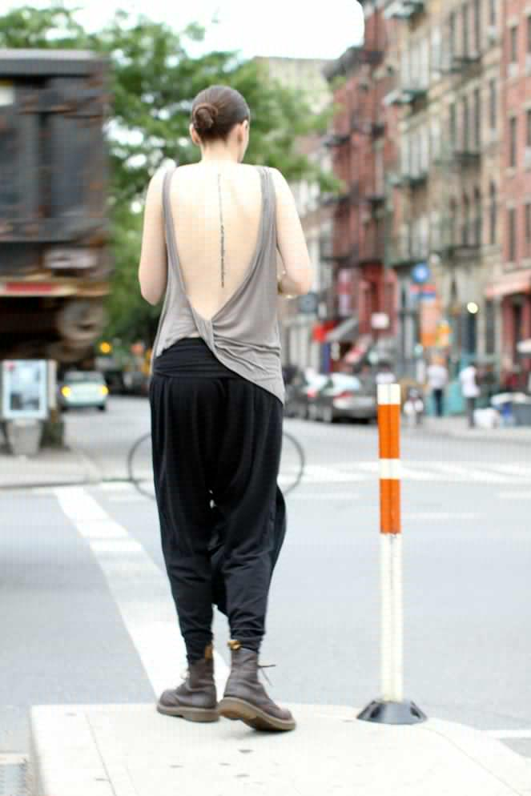

Figure 5: It reads: ‘When birds look into houses, what impossible worlds they see.’

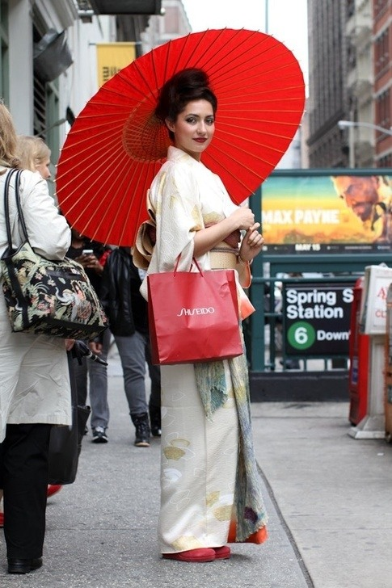

Figure 6: Make sure you can see the bag' 'Oh, I didn't realise you were advertising something.' 'Isn't everything beautiful advertising something?'

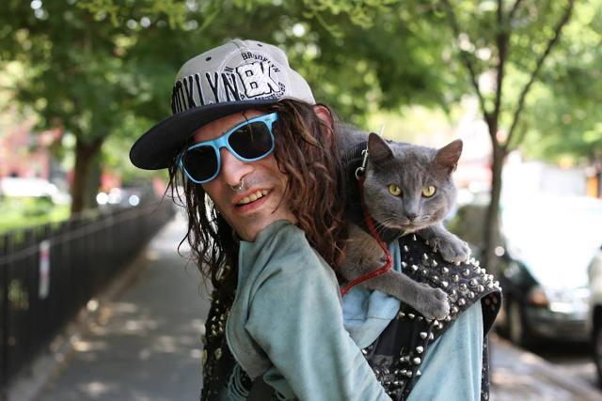

Figure 7: "I found him in the trash. I named him Shadow because he followed me everywhere." (New York City, July 2014)

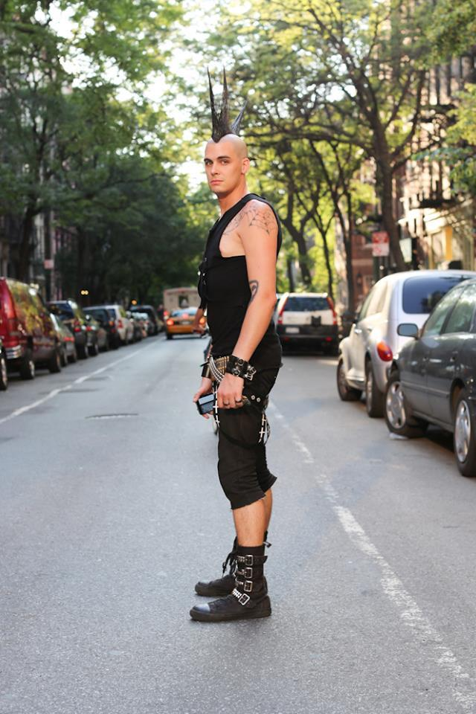

Figure 8: "I did 8.5 years on an attempted murder charge." "What happened?" "Some thirty-year-old dude kept harassing my twelve-year-old sister. He’d wait outside her school and invite her to parties. So I tried to kill him." (New York City, June 2014)

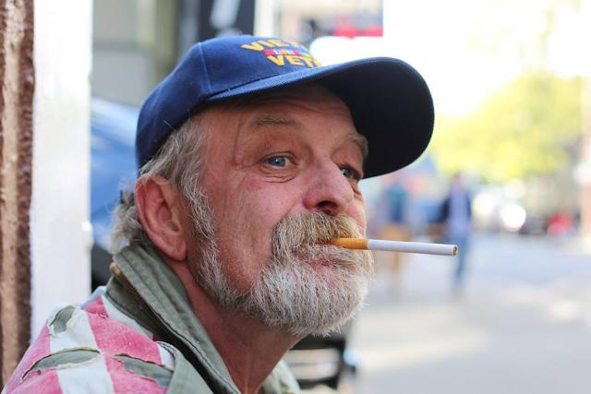

Figure 9: "Saddest moment? How am I supposed to choose between losing my parents and seeing my friends die in Vietnam? I don’t categorize those things. Listen, a person is like a rubber band ball. We’ve all got a lot of bad rubber bands, and a lot of good rubber, and they’re all wrapped up together. And you’ve got to have both types of bands or your rubber band ball ain’t gonna bounce. And no use trying to untangle them. You know what I’m saying?" (New York City, May 2014)”



Figure 10: "His owner told me that according to a Native American myth, dogs with different colored eyes can see both heaven and earth." (New York City, April 2014)

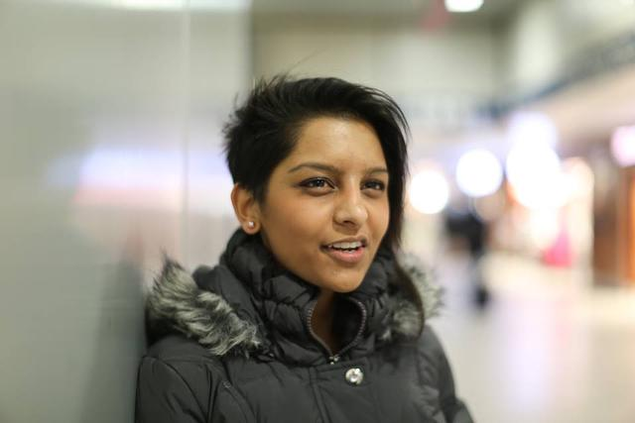

Figure 11: "A coworker asked for my number the other day. My friends overheard and said: ‘He must have a thing for Indians.’ I was like, ‘Or maybe I’m just really f***ing cool.’" (New York City, March 2014)

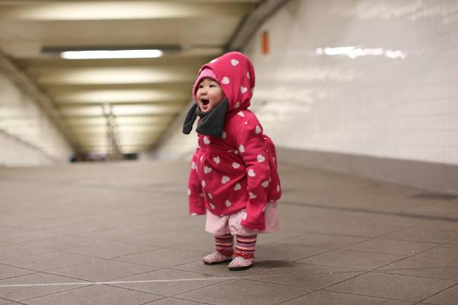

Figure 12: (New York City, February 2014)

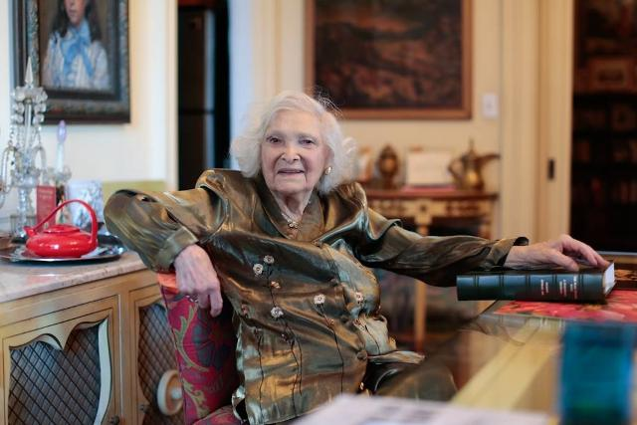

Figure 13: "When I was 19, my girlfriend and I were going to study in Paris. Our boyfriends came to the docks to see us off. Right as we were getting on the ship, my friend’s boyfriend said to her: ‘If you go, I won’t wait for you.’ So she turned around and decided to stay. My fiancé saw this and told me: ‘I won’t wait for you either.’ I said: ‘Don’t!’” (New York City, January 2014)

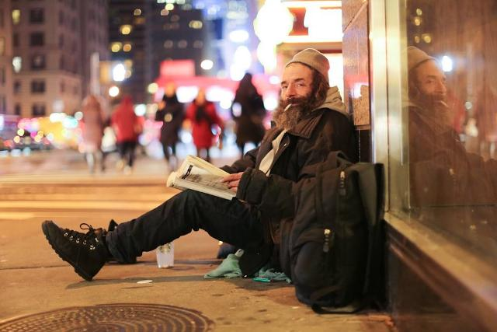

Figure 14: "I’ve got a whole stack of books in my cart. Most of them are advance copies. I know a place where they get thrown out." “How many books have you read?” “Thousands.” “So why are you homeless?” “I’ve tried to work a job a bunch of times. But then I get sad, and then I get high, and things fall apart.” (New York City, December 2013)



Figure 15: "I used to be a preschool teacher, but I got fired." “What happened?” “Well, I decided that I wanted to have a socially conscious class. So we learned about apartheid in South Africa. Then we learned about homelessness. Then we made Mother’s Day cards for Trayvon Martin’s mom. And I think the principal decided that it was too much for three- and four-year-olds, because she told me I wasn’t a ‘good fit.’ But honestly, I was just shining too bright for them. And now she’s going to see me on Humans of New York, and she’ll be sorry!” (New York City, November 2013)

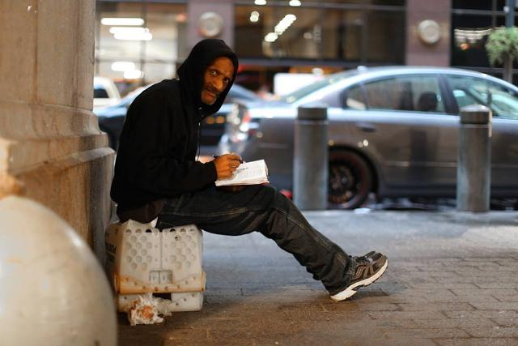

Figure 16: "My daughter lives in Pennsylvania. She’s working at a nursing home and studying to be an accountant. She’s my pride and joy." "Does she know you’re homeless?" "No, she’s got enough to worry about. I just tell her that I’m retired." (New York City, October 2013)

1. Stanton, B. About Retrieved from http://www.humansofnewyork.com/about
2. Ghannam, J. (2016, April ). *Media as a form of aid in humanitarian crises - center for international media assistance*. Retrieved August 30, 2016, from http://www.cima.ned.org/resource/media-as-a-form-of-aid-in-humanitarian-crises/
3. Stanton, B. About Retrieved from http://www.humansofnewyork.com/about
4. Series. Retrieved from http://www.humansofnewyork.com/series
5. Cunningham, V., Bans, L., Bietz, B., Sipress, D., Davidson, A., Wiener, A., … Gopnik, A. (2015, November 4). Vinson Cunningham. Page-Turner. Retrieved from http://www.newyorker.com/books/page-turner/humans-of-new-york-and-the-cavalier-consumption-of-others
6. Park, Y., Heo, G. M., & Lee, R. (2011). Blogging for informal learning: Analyzing Bloggers’ perceptions using learning perspective. Journal of Educational Technology & Society, 14(2), 149–160. doi:10.2307/jeductechsoci.14.2.149
7. BARNES, C. (2012). Citizen journalism vs. Traditional journalism: A case for collaboration. Caribbean Quarterly, 58, 16–27. doi:10.2307/41708775
8. Smith, R. *Agenda-setting, priming & framing*. Retrieved August 31, 2016, from http://faculty.buffalostate.edu/smithrd/PR/Framing.htm